|  |
| --- |
| Sotaro yoshimoto  1 559 588 4242  [Sotaro.yoshimoto@gmail.com](mailto:Sotaro.yoshimoto@gmail.com) |
| Results-oriented Web Developer and Blockchain Developer with considerable training and enterprise experience in Web site design and in coding, and testing of Web applications, and in the formation, planning, and implementation of online business ventures. |

# Experience

|  |
| --- |
| Jul 2021 – cURRENTSoftware engineer, **SoROC TEchnology** VAughan, CA Develop Blockchain Platform   * Built from scratch marketplace in NextJS in four months. * Design and build patterns of chains and mainly developed Cross-Chain by Solidity, Rust & Web3.js * Develop an analytics engine for the marketing team to help them understand the marketing ROI  oct 2018 – May 2021Full Stack developer, xtream milano, italy Developed XTREAM Company Website   * Ported the lonic Angular Sales funnel to React and GraphQL for rapid prototyping and split testing. * Ported the deprecated native lonic library to Webpack 5 speeding up local and remote builds up to 6x. * Developed a no-escape method that increases local development speed by a factor of 10 in your workflow * Ensuring quality standards through regular code reviews of contractor’s codebase contributions.   Developed Job Platform   * Developed a job market platform in Node.js with MongoDB and ReactJS. * Created the “PAYMENT INTEGRATION” using Chargebee. * Integrated Stripe API to make payments  nov 2015 – Sep, 2018Full Stack Developer, **Gruppo roncaglia** Roma, italy Develop Blockchain Platform   * Participated in pair programmed with 3 engineers, and reviewed team’s code to provide additional perspective and catch previously missed errors. * Worked with Quality Assurance to get new pages/products tested, and addressed any issues within 48 hours * Designed and implemented web applications along with 3rd-party software integrations as a web team liaison for all inter-departmental and customer-facing projects. * Cooperate with designers to create clean interfaces and simple, intuitive interactions and experiences. * Developed E-commerce sites, Sports sites with Codeigniter, Zend and Spring Framework and React. * Developed several websites using ReactJs, AngularJs, VueJS as a javascript framework  dec 2014 – sep, 2015Backend Developer, **joho technology** tokyo, japan  * Developed the Database of 20 websites of all sorts of education, management of students, course, scores sand tests for using MySQL, PostgreSQL. * Completed 25 backend projects successfully as well using PHP, Laravel, CoeIginiter with Strong background in a variety of database platforms such as MySQL, MongoDB, PostgreSQL  Sep 2013 – Aug, 2014Software engineer, pikkles tokyo, japan  * Designed and developed Front-end GUI for 12 applications using HTML/CSS, Bootstrap, JavaScript. jQuery and Ajax. * Completed of training in UX and UI design implementation * Collaborated with desingers, project managers and developers and communicated clearly by using Slack, Skype, Jira, Zoom meeting and google meeting. |
|  |

# Education

|  |
| --- |
| Sep 2009 – Aug 2013Bachelor’s degree, The university of tokyoComputer and information science and support services. |
|  |

# Skills

|  |  |
| --- | --- |
| **Web Development**   * HTML/CSS/BootStrap * JavaScript/TypeScript * ReactJS + React Native (Material UI, NextJS[SSR]) * VueJS * NodeJS / Express / NestJS * PHP with OOP, Laravel, CodeIgniter | **Blockchain**   * Web3.JS, Ethereum, Solana * ERC20, ERC777, ERC223, ERC721, ERC1155 Smart Contract Development * Crypto Collectible Platforms and Non-Fungible Tokens * Impermanent loss, governance tokens * P2P/Pool Lending and Borrowing |

# Projects

Job Platform

* Developed a job market platform in NodeJS with

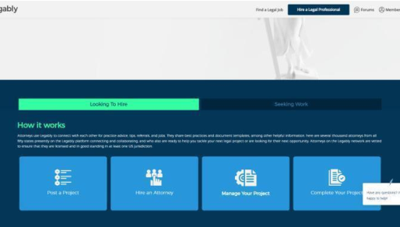

MongoDB and ReactJS

* Created the “Payment Integration” using Chargebee.
* Integrated Stripe API to make payments

https://www.legably.com/

Advertisement Website

I have a project in progress and the client wanted to finish

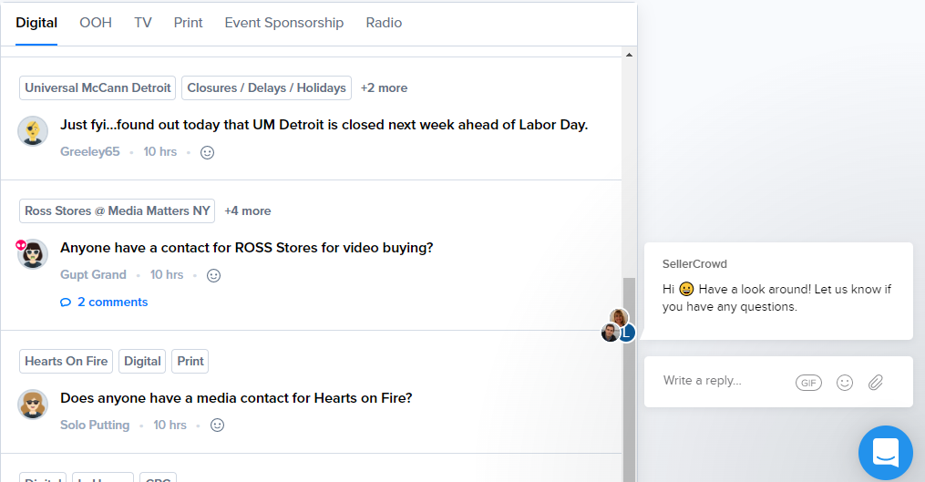

It in urgent. I worked 50 hours a week and completed it in

Time. My role was React Full-Stack web developer in this

Time.

https://sellercrowd.com/

NFT MarketPlace

NFT Marketplace by Solidity, Web 3. Js and Next.JS.

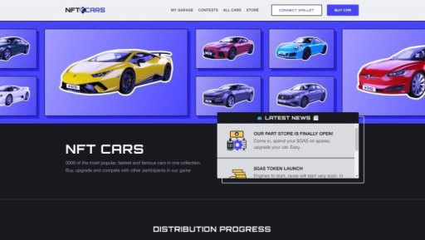

My role was Smart Contract developer as well as web

Developer

https://nftcars.me/